Town of Altavista
Water System and the Staunton River…

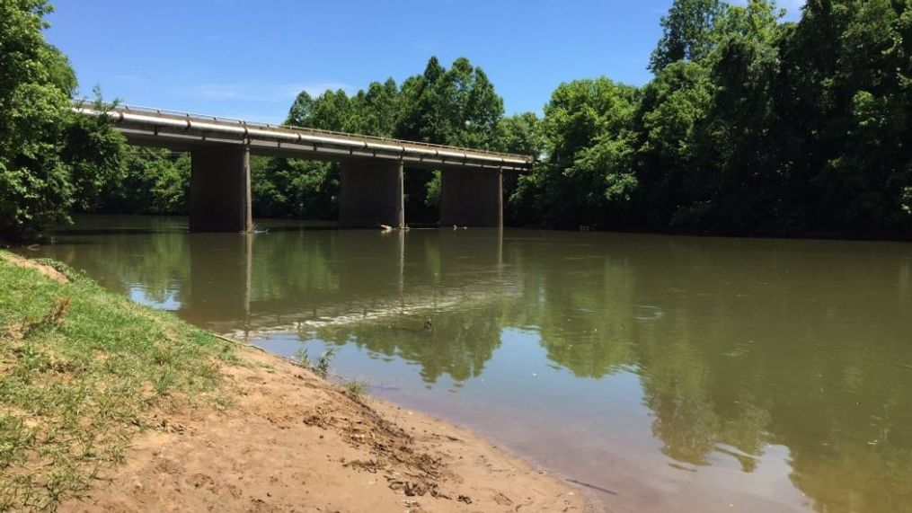

Always be vigilant and help us protect our water system and our water sources.

Please report any suspicious activity or spills to your Public Works Department at 434-369-5001, ext. 147; or the Water Treatment Plant at 434-324-7251.

It is a pleasure to serve our community.
We appreciate each and every one of you.

